**American International University- Bangladesh**

DATABASE PROJECT ON SUPER SHOP

Farhan Rahman Arnob

ID#13-24160-2

Sumaya Jahan

ID#13-24607-2

INDEX

|  |  |
| --- | --- |
| Table of Contents | Page |
| 1.Business and System Summery | 3 |
| 2. Overview of Business Environment and Project Objectives | 3-4 |
| 3. Summarization of the Developed Database | 4 |
| 4. Justification from my side in the database | 4 |
| 5. An ERD Diagram in the original | 5 |
| 6.Normalization up to 3rd Normal form | 5-6 |
| 7. A relationship diagram after normalization | 6 |
| 8.Creating table | 6-13 |
| 9.Screenshot of Sample data of Table | 13-18 |
| 10.Sample and complex views | 19-20 |
| 11.Screen shot of all over database | 21 |

***Business And System Summary :-***

A to Z point is established in 2010 to make traveling fun and comfortable for the all classes of people of home and abroad. The head office of the company is situated at gulshan, Dhaka. There are many branches of the company around Dhaka city. Every branches has a manager with sufficient employees.

A to z point provides various kind of products for customers. Customers can come for shopping for any products that is offered by the shop. As the shop system, any branch of A to Z point is to take customers orders for Products. According to the customers shoppings a bill slip is generated automatically which is checked by agency manager later and sent to the belonging customer. As far the shop system customer pay his/her payment using the billing slip. Customer’s payment is confirmed by manager if the payment is ok then the shopping has been confirmed for the customer.

From this discussion, we have identified the data entities required in the data model for the A to Z point: customers,shopping,products,bill,manager

***Overview of Business Environment and Project Objectives:-***

A to Z point offers different productss. Each products has different product_id and producte_type. Customers come for shopping including products. Products have products_price. This price generate the bill. In pay slip there may be discount. And Finally the Net_total_amount. Customers pay their payment through billing_id. Billslip cannot be generate without shopping, and shopping cannot be generate without products.

Concerning the Customers:

1. A customer has an unique customer_id and a specific contact_number
2. A customers can request for one or many shopping. And many customers can come for many shoppings.

Concerning the shopping:

1. We record each shopping of client
2. Each shopping corresponds to a product
3. A shopping cannot exists without a product
4. And over time there will be many-to-one products for shopping

Concerning Employees:

1. Every employee has an unique employee_id
2. Every employee is managed by a manager

Concerning Manager:

1. Manager manage all salesman
2. Manager manage the shop.

Concerning products:

1. A products has an unique product_id and specific product-type and price
2. Shop has different products.

Concerning Bill:

1. A bill has an unique bill_id
2. A booking generate one billslip.

***Summerization of the Developed Database:-***

The database is developed thinking the both sides of the business shop and customers. Using this database a customer can choose products and can come for shopping. On the other other hand shop can operate it’s operation’s on on the basis of various aspect.

***Justification from my side in the database:-***

I think the database meets the business policy of A toZ point According to the business policy what the functions need to be operated by the shop that is possible using the database. Such as storing customer information, products description, bills description etc. On the other hand customers can gather informations what they need from the shop. Such as info about products, shoppings, bill etc. So I think this database can support the business succesfully.

Main er diagram



Normalization :

1 . Here no multi value . so, does not need 1nf.

2.Here has no composite key . so , does not need 2nf.

3. In employee table there is a transitive dependency on manager rank and commission .

(before normalization )

Manager:

|  |  |  |  |  |
| --- | --- | --- | --- | --- |
| Manager id | Employee id | Rank | Commission | Educational information |

(After normalization )

manager

|  |  |  |  |
| --- | --- | --- | --- |
| Manager id | Employee id | Rank | Educational information |

Bonus:

|  |  |
| --- | --- |
| rank | commission |

Schema Diagram After Normalization :

There are 18 Entity table and relationship tables to relate the tables.

1.shop

CREATE TABLE SHOP (

SHOP_ID VARCHAR2(13)PRIMARY KEY,

SHOP_NAME VARCHAR2(100),

ESTABLISHED_DATE DATE,

OWNER_NAME VARCHAR2(100),

WEB_ADDRESS VARCHAR2(50),

HEAD_OFFICE_ADDRESS VARCHAR2(200),

CONSTRAINTS SHOP_ID_CK CHECK (SHOP_ID BETWEEN '111-0000' AND '111-9999')

)

2.

CREATE TABLE BRANCH (

BRANCH_ID VARCHAR2(13)PRIMARY KEY,

SHOP_ID VARCHAR2(13),

BRANCH_NAME VARCHAR2(100),

BRANCH_ADDRESS VARCHAR2(200),

BRANCH_ESTABLISHED_DATE DATE,

BRANCH_EMAIL_ID VARCHAR2(60),

BRANCH_PHONE VARCHAR2(11),

CONSTRAINTS PHONE_CK CHECK( BRANCH_PHONE BETWEEN 01000000000 AND 01999999999 ),

CONSTRAINTS BRANCH_ID_CK CHECK (BRANCH_ID BETWEEN '121-0000' AND '121-9999'),

FOREIGN KEY(SHOP_ID) REFERENCES SHOP(SHOP_ID)

)

3.

CREATE TABLE VEHICLE (

VEHICLE_ID VARCHAR2(13) PRIMARY KEY,

BRANCH_ID VARCHAR2(13),

VEHICLE_NAME VARCHAR2(30),

VEHICLE_TYPE VARCHAR2(20),

FOREIGN KEY (BRANCH_ID) REFERENCES BRANCH(BRANCH_ID),

CONSTRAINTS VEHICLE_ID_CK CHECK ( VEHICLE_ID BETWEEN '131-0000' AND '131-9999' )

)

4.

CREATE TABLE EMPLOYEE(

EMPLOYEE_ID VARCHAR2(13) PRIMARY KEY,

BRANCH_ID VARCHAR2(13),

EMPLOYEE_NAME VARCHAR2(30),

EMPLOYEE_PHONE VARCHAR2(11),

EMPLOYEE_ADDRESS VARCHAR2(100),

EMPLOYEE_BIRTH_DATE DATE,

JOINING_DATE DATE,

SALARY NUMBER DEFAULT (5000),

JOB_TYPE VARCHAR2(50),

WORKING_ENTRY_TIME VARCHAR2(20),

WORKING_TIME NUMBER,

FOREIGN KEY(BRANCH_ID) REFERENCES BRANCH(BRANCH_ID),

CONSTRAINTS EMPLOYEE_PHONE_CK CHECK( EMPLOYEE_PHONE BETWEEN 01000000000 AND 01999999999 ),

CONSTRAINTS EMPLOYEE_ID_CK CHECK (EMPLOYEE_ID BETWEEN '141-0000' AND '141-9999')

)

5.

CREATE TABLE SALESMAN(

SALESMAN_ID VARCHAR2(10)PRIMARY KEY,

EMPLOYEE_ID VARCHAR2(13),

CONSTRAINTS SALESMAN_ID_CK CHECK( SALESMAN_ID BETWEEN 'SALE-0000' AND 'SALE-9999')

)

6.

CREATE TABLE PRODUCT (

PRODUCT_ID NUMBER PRIMARY KEY,

BRANCH_ID VARCHAR2(13),

PRODUCT_NAME VARCHAR2(30),

COMPANY_NAME VARCHAR2(20),

TYPE VARCHAR2(20),

MEASUREMENT_UNIT VARCHAR2(20),

COST_PER_UNIT NUMBER,

OFFER NUMBER,

PRODUCT_QUANTITY NUMBER ,

FOREIGN KEY (BRANCH_ID) REFERENCES BRANCH(BRANCH_ID)

)

7.

CREATE TABLE ELECTRONICS (

PRODUCT_SERIAL_ID NUMBER PRIMARY KEY,

WARRANTY_DATE DATE,

MODEL VARCHAR2(35),

MANUFACTURER_COUNTRY VARCHAR2(30)

)

8.

CREATE TABLE ELECTRIC_PRODUCT(

PRODUCT_SERIAL_ID NUMBER,

PRODUCT_ID NUMBER,

FOREIGN KEY (PRODUCT_SERIAL_ID) REFERENCES ELECTRONICS(PRODUCT_SERIAL_ID),

FOREIGN KEY (PRODUCT_ID) REFERENCES PRODUCT(PRODUCT_ID)

)

9.

CREATE TABLE CUSTOMER(

CUSTOMER_ID VARCHAR2(13) PRIMARY KEY,

BRANCH_ID VARCHAR2(13),

CUSTOMER_NAME VARCHAR2(40),

CUSTOMER_ADDRESS VARCHAR2(100),

CUSTOMER_PHONE NUMBER(11),

FOREIGN KEY (BRANCH_ID) REFERENCES BRANCH(BRANCH_ID),

CONSTRAINTS CUSTOMER_ID_CK CHECK (CUSTOMER_ID BETWEEN '151-000000000' AND '151-999999999')

)

10

CREATE TABLE HOME_DELIVERY_WORKER (

WORKER_ID VARCHAR2(13) PRIMARY KEY,

EMPLOYEE_ID VARCHAR2(13),

DELIVERING_AREA VARCHAR2(30),

DELIVERY_TARGET NUMBER,

VEHICLE_ID VARCHAR2(13),

FOREIGN KEY (VEHICLE_ID) REFERENCES VEHICLE(VEHICLE_ID),

FOREIGN KEY (EMPLOYEE_ID) REFERENCES EMPLOYEE(EMPLOYEE_ID),

CONSTRAINTS WORKER_ID_CK CHECK (WORKER_ID BETWEEN '161-0000' AND '161-9999')

)

11.

CREATE TABLE BONUS(

RANK NUMBER PRIMARY KEY,

COMMISSION NUMBER

)

12.

CREATE TABLE MANAGER(

MANAGER_ID VARCHAR2(13) PRIMARY KEY,

EMPLOYEE_ID VARCHAR2(13),

RANK NUMBER,

EDUCATION VARCHAR2(200),

FOREIGN KEY (RANK) REFERENCES BONUS(RANK)

)

13.

CREATE TABLE BILL(

BILLING_ID NUMBER PRIMARY KEY,

MANAGER_ID VARCHAR2(13),

CUSTOMER_ID VARCHAR2(13),

BILLING_DATE DATE,

FOREIGN KEY (MANAGER_ID) REFERENCES MANAGER(MANAGER_ID),

FOREIGN KEY (CUSTOMER_ID) REFERENCES CUSTOMER(CUSTOMER_ID)

)

14.

CREATE TABLE BILL_COST(

PRODUCT_ID NUMBER,

BILLING_ID NUMBER,

FOREIGN KEY (BILLING_ID) REFERENCES BILL(BILLING_ID),

FOREIGN KEY (PRODUCT_ID) REFERENCES PRODUCT(PRODUCT_ID)

)

15.

CREATE TABLE CUSTOMER_BILL(

CUSTOMER_ID VARCHAR2(13),

BILLING_ID NUMBER,

FOREIGN KEY (BILLING_ID) REFERENCES BILL(BILLING_ID),

FOREIGN KEY (CUSTOMER_ID) REFERENCES CUSTOMER(CUSTOMER_ID)

)

16.

CREATE TABLE FOOD(

FOOD_SERIAL_ID VERCHAR2(20) PRIMARY KEY,

MANUFACTURE_DATE DATE,

EXPIRE_DATE DATE

)

17.

CREATE TABLE MANAGER_EMPLOYEE(

MANAGER_ID VARCHAR2(13),

EMPLOYEE_ID VARCHAR2(13),

FOREIGN KEY (MANAGER_ID) REFERENCES MANAGER(MANAGER_ID),

FOREIGN KEY (EMPLOYEE_ID) REFERENCES EMPLOYEE(EMPLOYEE_ID)

)

18.

CREATE TABLE FOOD_PRODUCT(

FOOD_SERIAL_ID NUMBER,

PRODUCT_ID NUMBER,

FOREIGN KEY (FOOD_SERIAL_ID) REFERENCES FOOD(FOOD_SERIAL_ID),

FOREIGN KEY (PRODUCT_ID) REFERENCES PRODUCT(PRODUCT_ID)

)

Values:

Shop: 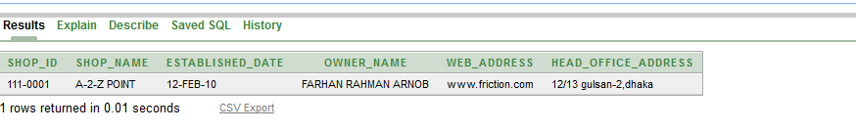

BRANCH:

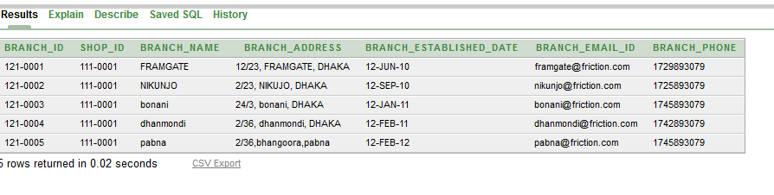

VEHICLE:

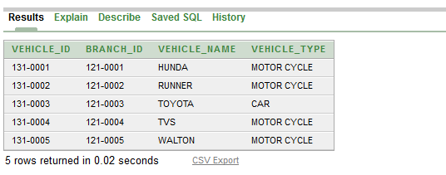

EMPLOYEE:

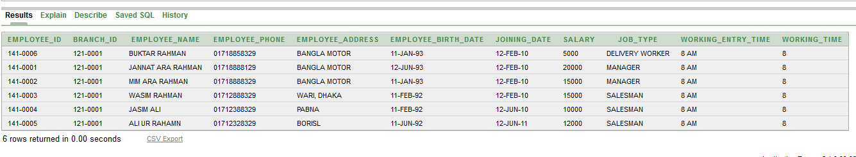

SALESMAN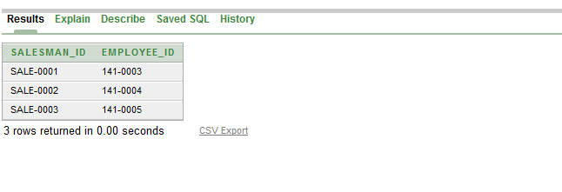

PRODUCT:

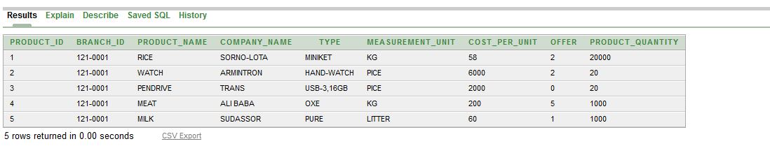

ELECTRONICS:

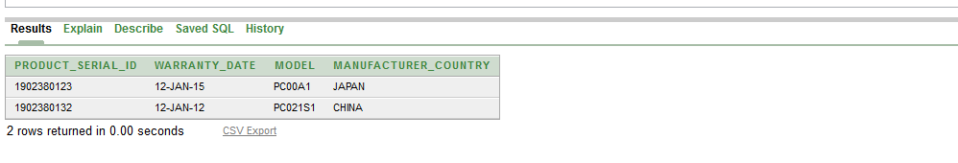

ELECTRIC_PRODUCT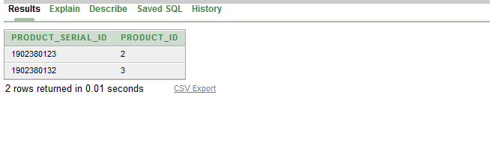

CUSTOMER: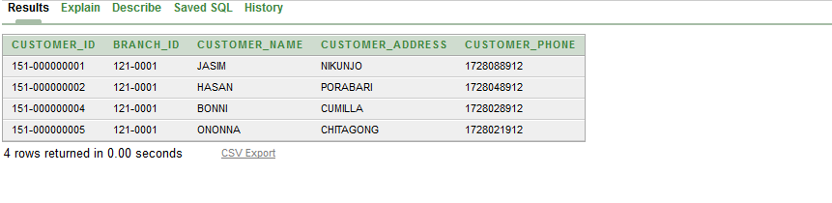

HOME_DELIVERY_WORKER:

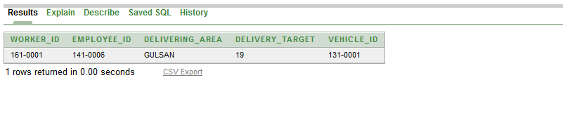

BONUS 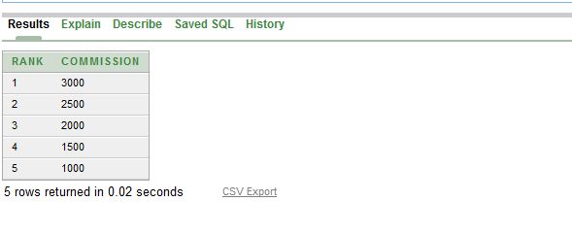

MANAGER

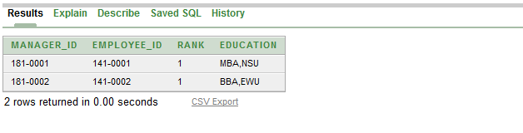

BILL:

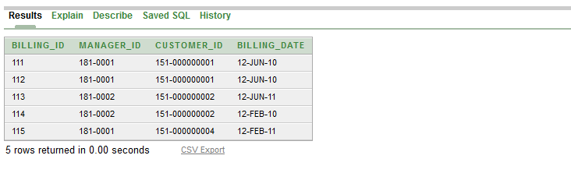

BILL_COST:

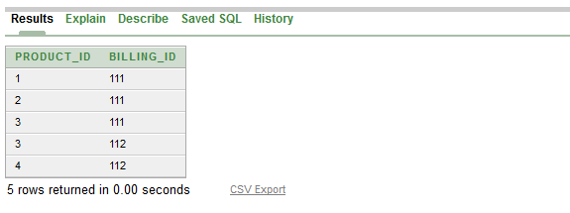

CUSTOMER_BILL:

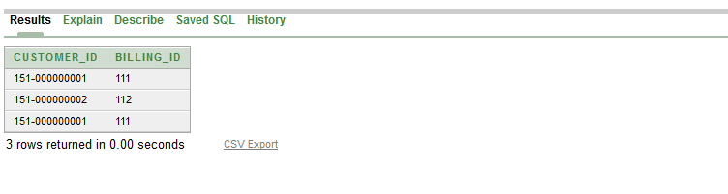

FOOD: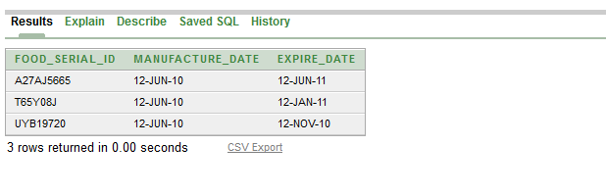

MANAGER_EMPLOYEE: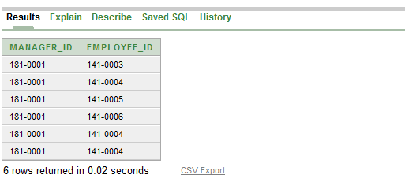

FOOD_PRODUCT:

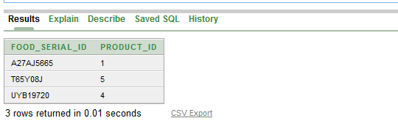

Some sql query and result:

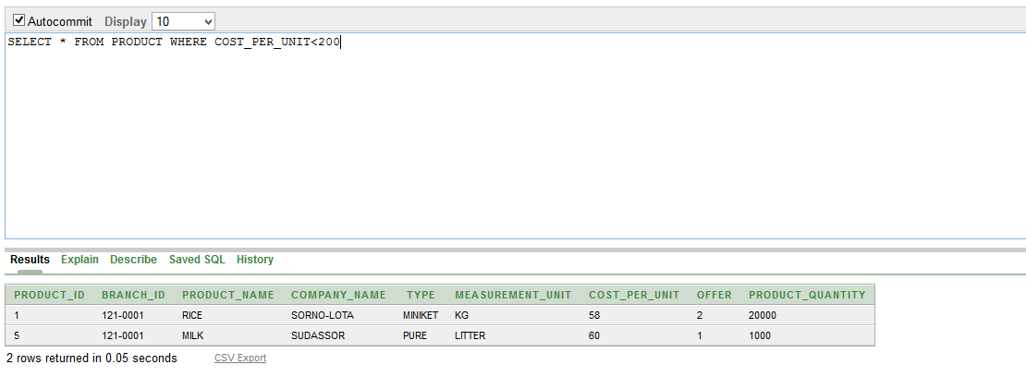

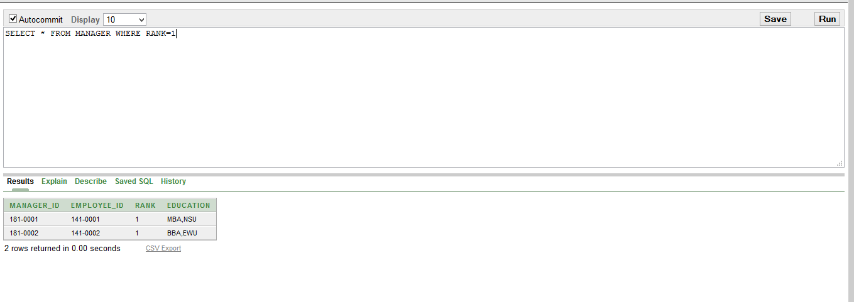

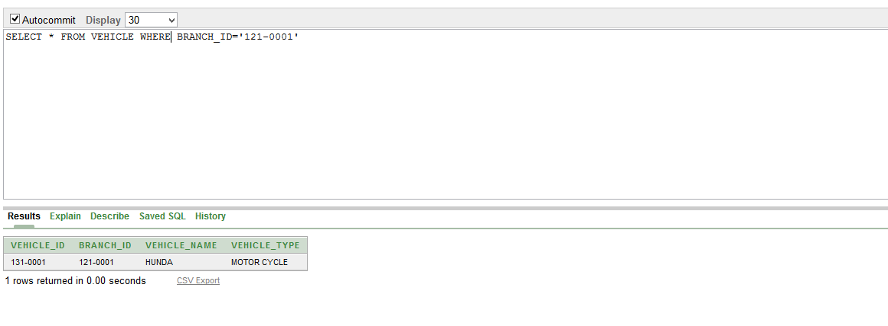

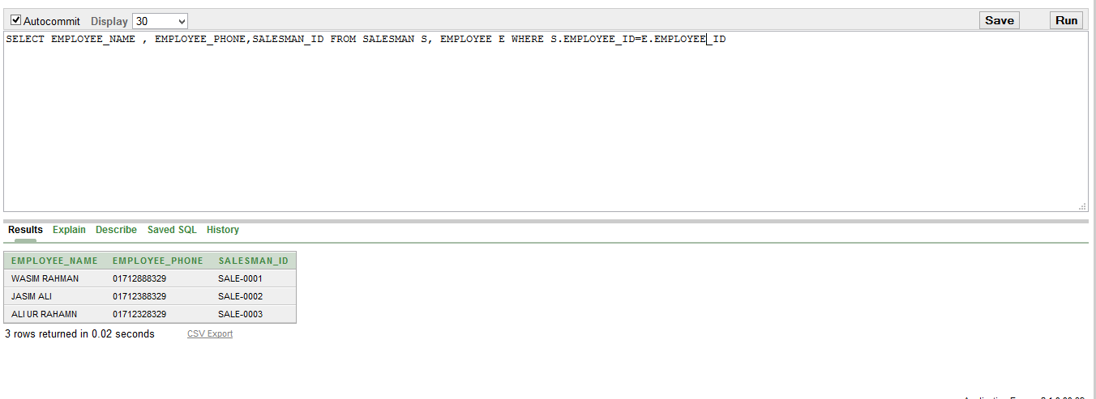

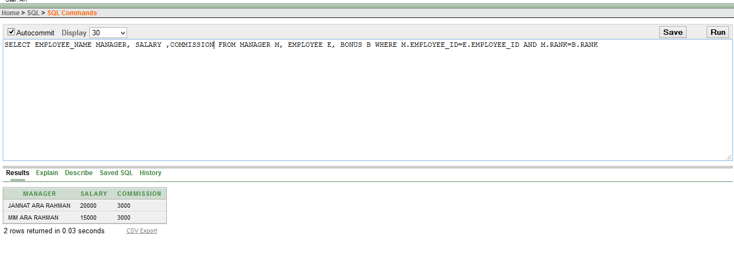

---------------------------------------------------------------------------------------------------------------------------------------------------------------------------------------------------------------------------------------------------------------------------------------------------------------

Over all project

